

International Institute of Tele-Medicine
Istituto Internazionale di Tele-Medicina


Polo Tecnologico Universitario di Desio
Technological University Centre of Desio

eGeH’14
e-government & e-health
11th International Meeting
(In the frame of Italian semester Presidency of European Union and towards EXPO 2015)

10 – 12 Luglio /July 10 – 12, 2014
Desio Hospital (Aula Magna 1° Piano/1st Floor)
Via Mazzini Desio (MB) - Italy


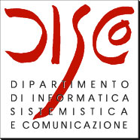




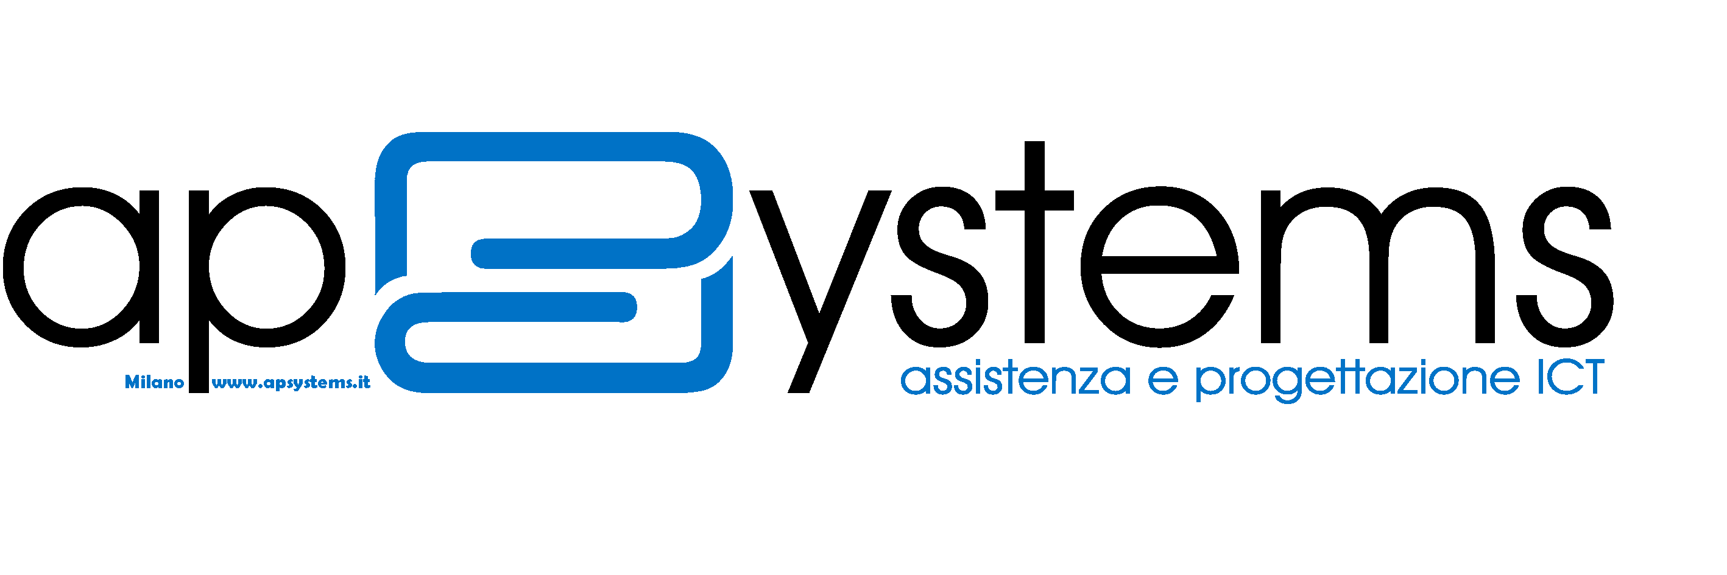


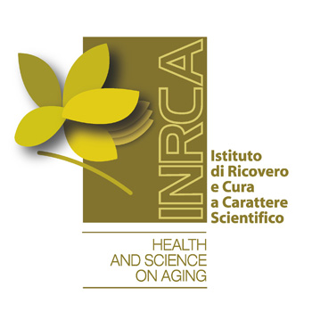
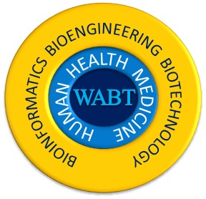
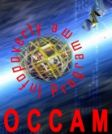

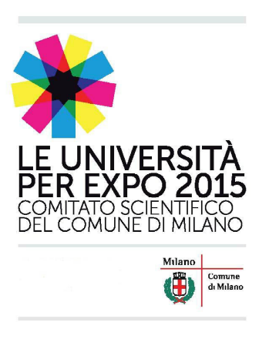
Program
Giovedì / Thursday 10
h 13.30 Registration
h 14.00 Introduction

- Francesco Sicurello (Presidente IITM)
- Giancarlo Mauri (Direttore Dip. Informatica, Univers. Milano-Bicocca)
- Pietro Caltagirone (Direttore Generale AO Desio-Vimercate)

h 14.30 Ambiente, Salute (Environment/Health) & ICT:
esperienze e insegnamenti scientifici e metodologici dall’evento diossina
- Paolo Mocarelli (Dirett. Scient. Don Gnocchi, Lab. Ospedale di Desio, Univers. Milano Bicocca)

h 15.00 Life Sciences, Big Data, e-Health; Luciano Milanesi (Istituto Tecnologie Biomediche, CNR Milano)

h 15.15 Sessione Speciale / Special Session for EXPO 2015: telemonitoraggio di alimentazione e salute per la prevenzione delle malattie (Francesco Sicurello, Paolo Mocarelli)

- Claudia Sorlini (President of the Scientific Committee for EXPO –Municipality of Milan)
- Gianluca Castelnuovo (Univ. Cattolica Milano, Istituto Auxologico - Ospedale San Giuseppe, Verbania)
- Maria Luisa Ganadu (Università Sassari)
- Giuseppe Marelli (Ambulatorio Diabetologia Ospedale di Desio)
- Alessia Fumagalli (INRCA Casatenovo Brianza)
- Antonio Colombo (Polo Neurologico Brianteo, Seregno)
- Ida Biunno (CNR, Milan)
- Enrico M. Staderini (Haute École d’Ingénierie et de Gestion du Canton de Vaud, Western Switzerland University)
- Paolo Cristiani (CBIM Pavia Italy)
- Pierpaolo Saporito (OCCAM- NU, Milano)

Venerdì / Friday 11

h 9.00 Welcome and opening of eGeH ‘14

h 9.15 e-Government, Smart Cities, smart media (Pasquale Tarallo, Senior Executive and Expert in Innovation Projects, Milano)

- ICT in Smart City; Renzo Bassetto (AP Systems)
- Ricerca, innovazione, e-government in ambito provinciale; Dario Parravicini (Provincia Milano)
- Servizi on line nella PA; Gaetano Pozzessere (INPS, Como)
- ICT in servizi sociali comunali; Carlo Todeschini (Metarete, Cremona)
- Smart Media e accesso a servizi per il cittadino; Maria Luisa Ganadu, Serena Succhi (Università Sassari)
- Developing Process Automation Software for e-Government; Dhori Terpo (University “E. Çabej”, Albania), Endri Xhina, Alda Kika (University of Tirana, Albania)
- Hierarchical Clustering Approach for Monitoring and Securing the Data in E-Government Systems; Hanaa M. Said, Mohamed Hamdy, Rania El Gohary, Abdel-Badeeh M. Salem (Ain Shams University, Cairo, Egypt)

h 11.00 Coffee Break
h 11.15 e-Health and Information Systems (local, regional…) (Mauro Miserendino, Senior Journalist expert in health informatics)

- Sistema informativo ospedaliero integrato; Giovanni Delgrossi (A.O. Desio-Vimercate)
- Sistema informativo del Medico di Medicina Generale; Giuseppe Rivolta (Snami)
- ORTHOME®: one-year results of web orthoptic rehabilitation and IGOR®: Internet Group Ophthalmology Report. Social, medical and economical evaluation on a web medical application in teleophtalmology; G. Fanton, F. Posteraro, R. Olent, A. Mazzone, G. Piana, V. Marinaccio (SolMed Tech, Novara)
- RIS/PACS integration; Gabriele Concordia (Radiology Dept., CTO Hospital, Milan), Riccardo Orsini (RIS/PACS Manager, Presid. AIT@SIT)
- Second Opinion WebPortals: A documented approach for remote diagnosis and prevention; Daniel Barcan (Teleradiology Services International Medsoft Group, Romania)
- E-Health in Horizon 2020; Judita Kinkorova (Technologické centrum AV ČR, Praha, Czech Republic)

h 13.00 Lunch Break
h. 14.15 e-Health, Ageing, e-Care (Eugenio Santoro, Istituto di Ricerche Farmacologiche "Mario Negri", Milan)

- The Adoption of “Silver” E-health Technologies First Hints on Technology Acceptance Factors for elderly in Italy; Elena Bellio, Luca Buccoliero (Bocconi University of Milano)
- A System Oriented Architecture for the direct EHR data reuse in Infective diseases and ophthalmology; R. Gazzarata, B. Giannini, A. Tagliati, M. Bonetto, M. Giacomini (University of Genoa)
- Progetto Smart Aging; Marialisa Lamonica (Associaz. Smart Aging), Stefano Puricelli,Paolo Cristiani (CBIM Pavia Italy)
- European I-CARE project: Internet - Caregivers of Alzheimer individuals Relief and Education: a single-blinded randomized clinical trial; Olivier Beauchet (Angers University Hospital & Biomathics, France), Denis Granger (PatientsWorld.com)
- Developing e-health data analysis tool by means of Weka; Alda Kika, Endri Xhina (University of Tirana, Albania), Ridvan Alimehmeti (University of Medicine, University Hospital Center “Mother Theresa”)

h 16.00 Break
h. 16.15 Biomedicine, Epidemiology, ICT for Statistical Data Analysis and Mining (Paolo Brambilla, Clinical laboratory, Desio Hospital)

- ICT in Biomedicine; Italo Zoppis, Giancarlo Mauri (Univers. Milano-Bicocca)
- BioInfoTechnomics; Giuseppe Tritto (WABT - ICET, Paris, France – WEIL, Budapest, Hungary)
- Biomedical research in cognitive diseases; Roberto Dominici (Clinical Laboratori, AO Legnano-Magenta)
- Data Base in Epidemiology; Alfredo Nicolosi (Institute of Biomedical Technologies, CNR)
- Bio-Statistical methods and software; Piermario Gerthoux (IITM/@ITIM, University of Milan Bicocca)
- Stochastic networks models; Nicoletta Sabadini (Univ. Insubria, Como)
- Clinical Practices in the History of Medicine; André-Julien Fabre (International Society of Medicine, France)

h 20.00 Social dinner

Sabato / Saturday 12

h. 9.30 International Medical Informatics & Telemedicine (IMIT) community for cooperation

- Francesco Sicurello (President of IITM/IMIT)
- Abdel. M. Salem (Medical Informatics and Knowledge Engineering Research Unit, Ain Shams University, Cairo-Egypt)
- Judita Kinkorova (Technologické centrum AV ČR, Praha, Czech Republic)
- Hassan Ghazal (University Mohammed First, Nador, Morocco)
- Piermario Gerthoux (IITM/@ITIM)
- Alda Kika (University of Tirana, Albania)
- Enrico M. Staderini (Haute École d’Ingénierie et de Gestion du Canton de Vaud, Western Switzerland University)
- Mohamed Abdalla (EMMIT Regional Chapter of IMIT, Egypt)
- Hector Villanueva (LAMIT – Latino American Medical Informatics and Telemedicine – IMIT Regional Chapter, Peru)

h. 11.45 . Discussion, next international events (as IMIT in Buenos Aires on March 2015), closing

Chairman: Francesco Sicurello,
President of International Institute of Tele-Medicine (IITM),
University of Milano – Bicocca, Coordinator of PTUD
International Scientific Committee
Abdalla Mohamed | Senior Technical Advisor of ITU, Cairo Egypt
Abdel-Badeeh M. Salem | Ain Shams University Cairo, Egypt
Al-Shorbaji Najeeb Mohammed | WHO Knowledge management and sharing, Geneve
Ayad Essam | University of Cairo, Egypt
Bahnassy Ahmed | King Saud bin Abdulaziz for Health Sciences, Saudi Arabia
Borrillo Josephine | Adv Telehealth, USA
Brugi Miranda | University of Ferrara, Italy
Buccoliero Luca | Bocconi University of Milan
Castelnuovo Gianluca | Italian Institute for Auxology & Catholic University Milan
Celler Branko | University of New South Wales Sydney, Australia
Chandra Charu | University of Michigan, Dearborn, U.S.A.
Colantonio Angela | University of Toronto, Canada
Costin Hariton | Grigore T. Popa University of Medicine and Pharmacy, Iasi, Romania
Di Pietrantonio Loris | European Commission, Bruxelles, Belgium
Di Tommaso Angela | Fondation of Cancer “T. Campanella” Catanzaro
Dobnikar Ales | Ministry of Public Administration, Republic of Slovenia
Dondog Jargalsaikhan | Together Fund for Health NGO, Mongolia
Ettarres Yamma | Virtual University of Tunis, Tunisia
Ferrari Domenico | Catholic University of Piacenza Italy
Frize Monique | University of Ottawa, Canada
Gatti Fioretta | University of Bogotà, Colombia
Ghazal Hassan | University Mohammed First, Nador, Morocco
Gilardi Maria Carla | CNR & San Raffaele Hospital, Milan, Italy
Glinkowski Wojciech | Medical University of Warsaw, Poland
Gopalakrishnan Nair | TIM, PMU. Kingdom of Saudi Arabia & DS Institutions, Bangalore
Guffanti Enrico | INRCA Casatenovo Brianza, Italy
Iluyemi Adesina | NEPAD UK/Europe
Ishikawa Kiyomu | Hiroshima University, Japan
Jaucokic Novak | University of Montenegro
Kinkorova Judita | Technologické centrum AV ČR, Praha, Czech Republic
Kun Luis | National Defense University, Washington USA
Kwasnicka Halina | Wroclaw University of Technology, Poland
Lu Jie | University of Technology, Sydney Australia
Markowska-Kaczmar Urszula | Wroclaw University of Technology, Poland
Margan Anamarija | Virtual Policlinic Cres island , Croatia
Marini Sana Daya | American University of Beirut, Lebanon
Mauri Giancarlo | University of Milano-Bicocca, Italy
Misuraca Gianluca | Ecole Polytechnique Federale de Lausanne, Switzerland
Mocarelli Paolo | Institute IRCCS “Don Gnocchi”, University of Milano Bicocca
Moisil Ioana | University of Sibiu, Romania
Monteagudo Pena Josè Luis | Instituto de Salud Carlos III- Madrid, Spain
Pannone Immacolata | Italian Ministry of Foreign Affairs
Raad Mohamed Wasim | King Fahd University of Petroleum & Minerals, Dhahran, SA
Sabadini Nicoletta | University of Insubria, Como Italy
Salzano Gabriella | University of Marne-La-Vallée, France
Sangal Al K. | Scientific Committee Of Indian Telemedicine Society
Saporito Pierpaolo | OCCAM - UN
Santoro Eugenio | IRCCS-Mario Negri Institute for Pharmacology Research, Milan
Schrader Thomas | University of Applied Sciences Brandenburg, Germany)
Simon Pal | Templar Co, Semmelweis University, Budapest, Hungary
Solomonides Tony | University of Bristol, UK
Sorrentino Maddalena | University of Milan, Italy
Staderini Enrico M. | Western Switzerland University of Applied Sciences, Swisse
Stolyar Valery | Russian Academy of Medical Sciences, Russia
Sturkenboom Miriam | Erasmus University Rotterdam, The Netherlands
Tverdokhlebov Nikolay | Russian Academy of Sciences, Russia
Waegemann Peter | Medical Record Institute, Boston, USA
Yukako Yagi | Massach. General Hospital, Harvard University, Boston, USA
Zolfo Maria | Institute of Tropical Medicine, Anvers, Belgium

Contact Person: Patrizia Magretti
tel. +39 0362 1972283 ; e-mail: segreteria@iitm.eu

Registration form
Desio University T
eGeH’14
e-government & e-health
10th International Conference

July 10 – 12, 2014
Ospedale Desio /Monza e Brianza (Italy)

Last Name:
First Name:
Institution, Organization:
City:
Country:
Phone.:
e-mail:
Conference registration fee
- Individual participant: € 250,00  - Institutional-Enterprise: € 500,00 |  | - @ITIM/IMIT Member: € 100,00  - @ITIM/IMIT Institutional-Enterprise: € 200,00
- Student participant: € 100,00 |  | - Student @ITIM/IMIT Member : € 30,00

2014 IMIT (International Medical Informatics & Telemedicine) Membership Fee
- Individual member € 80,00
- Student member € 40,00
- Sponsor Member (€ 200,00 minimum)
- Institutional/Enterprise member (€ 250,00 minimum)

@ITIM Italian Association Membership Fees
- Individual member € 70,00
- Student member € 35,00
- Sponsor Member (€ 250,00 minimum)
- Institutional/Enterprise member (€ 300,00 minimum)

Data and Bank coordinates for payment:

For more information on participation modalities, please contact:
Patrizia Magretti, e-mail: segreteria@iitm.eu

